**Simulation of Electrical Switch for Water Irrigation**

Design a c program to simulate operation of an electrical switch where the program takes input values either 1 or 0 representing the switch being off or on resp. Using a suitable conditional statement the program should interpret the input values and display the corresponding condition as on or off. Additionally the program should handle invalid input values and provide appropriate error messages.

**TOPIC NAME - WATER IRRIGATION**

**1) RESEARCH** -

switch is an electrical device that is used to break or make electrical circuits. switches have many types SPDT,SPDT ,DPST SPDT.They have application in residential lighting as dimming on of control mobile phones for power on off volume control also in automobile for the light control.In C language switch is powerful decision making construct that simplify handling multiple condition .switch has application in C as controlling device as ATM machine ,calculator, gives command and option ,in game development also handling the event .

**LINK-**

[www.waelectronics.com](http://www.waelectronics.com)

[www.anypcba.com](http://www.anypcba.com)

[www.codrey.com](http://www.codrey.com)

**2) ANALYSIS -**

-Program continuously monitors soil moisture using a loop.  
-input is valid (0–100)  
- threshold (30%):  
-If below threshold → Pump ON  
-If equal or above threshold → Pump OFF

**3)IDEATE-**

algorithm -

**Step 1:** Start

**Step 2:** input - soil moisture (0-100)

**Step 3:** process **-**

0 - pump is off- no water flowing

1 - pump is on - water flowing

**Step 4:** output-

0 - switch off

1 - switch on

**Step 5:** End

**4) BUILD -**

#include <stdio.h>

int main() {

int soilMoisture; // Soil moisture value (0-100)

int moistureThreshold = 30; // Threshold below which water is needed

int pumpStatus; // 0 = OFF, 1 = ON

printf("Automatic Water Irrigation System Simulation\n");

while(1) { // Continuous monitoring

printf("\nEnter current soil moisture level (0-100, -1 to exit): ");

scanf("%d", &soilMoisture);

if (soilMoisture == -1) {

printf("Exiting the system...\n");

break;

}

if (soilMoisture < 0 || soilMoisture > 100) {

printf("Error: Invalid input! Enter 0-100.\n");

continue;

}

if (soilMoisture < moistureThreshold) {

pumpStatus = 1; // Pump ON

} else {

pumpStatus = 0; // Pump OFF

}

printf("Soil Moisture = %d%% → Pump Status = %d\n", soilMoisture, pumpStatus);

}

return 0;

}

**5) TESTING**

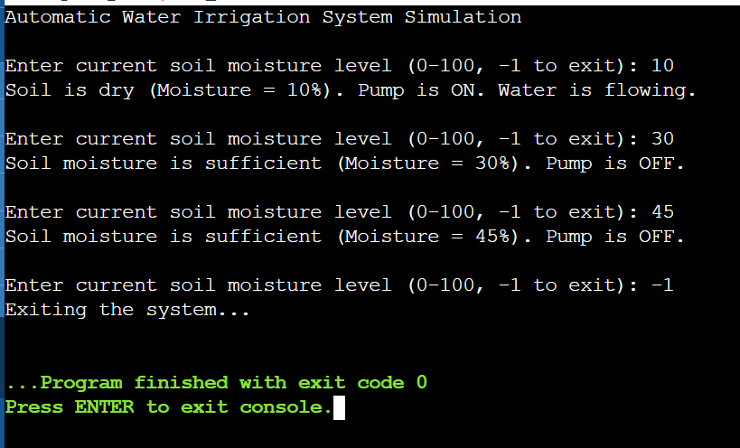

**6) IMPLEMENT -**